Genetta Butler and Rob Lecel

Final Project

Mission Period, 1769-1834 Timeline

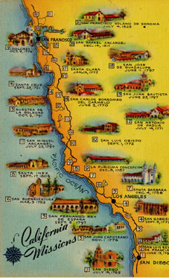

Prepared for:

Dr. Ruben Mendoza

SBS 220/320s

Hispanic California, 1542-1848

Fall 2004

